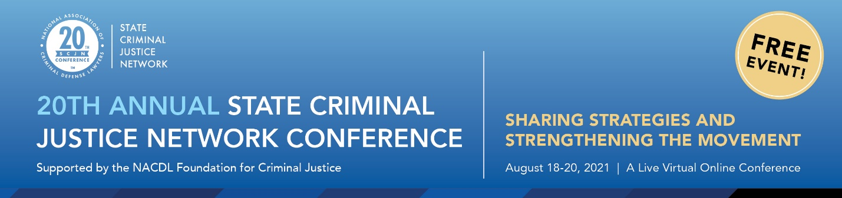

August 2021
Dear Friends,

Welcome to NACDL’s 20th Annual State Criminal Justice Network Conference: Sharing Strategies and Strengthening the Movement. I would like to take this opportunity to welcome you on behalf of Martín Sabelli, NACDL President; the NACDL Foundation for Criminal Justice; and NACDL’s State Legislative Affairs Committee.

This time last year, we embarked on our first virtual State Criminal Justice Network Conference due to the COVID-19 pandemic. Unfortunately, today we find ourselves still having to contend with the ongoing pandemic, in our personal and professional lives, as well as its impact on our criminal legal system, particularly as it relates to individuals who are currently incarcerated in our nation’s jails and prisons. Since the start of the pandemic, the nation’s top COVID-19 hot spots have included correctional facilities. And despite the tireless efforts of advocates to get people released, decisionmakers have been reluctant to do so. Even as the vaccine has become more widely available, the vaccination rate among incarcerated individuals and prison staff lag behind the national average. According to the Behind Bars Data Project at the University of California, Los Angeles, 64 percent of incarcerated individuals have been vaccinated, and only 47 percent of prison staff have received at least one dose of a vaccine – while 71 percent of all U.S. adults have been vaccinated. With many correctional officers declining to receive the vaccine, incarcerated individuals remain at a disproportionately high risk for infection.

Yet in spite of all that has transpired, this past year has proven that state legislative advocacy has the potential for driving reform, as you will hear from many at this year’s conference. Although we face challenges to reform that sometimes feel insurmountable, we are encouraged by all of you who, in various ways, support reform and equity in the criminal legal system. A host of state special sessions have provided for long-awaited reforms, as many states examined the need for systemic police reform in the context of nationwide protests in response to the continued killings of Black Americans by law enforcement. According to the National Conference of State Legislatures, all 50 states and the District of Columbia introduced legislation to reform some aspect of policing, including addressing issues around accountability and oversight, limiting the use of neck restraints and no-knock warrants, instituting use of force standards, requiring a duty to intervene, requiring increased use of body cameras, and more, which will be discussed during “A Year in Police Reform: Past Successes & Looking Ahead.”

This year’s conference, we have assembled the nation’s leading experts to discuss a number of pertinent state criminal justice reforms issues. Two panels will feature discussions on topics pertaining to two soon to be released NACDL reports on predictive policing and abortion criminalization. Stay tuned!

In addition, NACDL continues to provide advocates and its state affiliate organizations with resources aimed at assisting you with your legislative efforts. Below please find some of NACDL’s state advocacy resources:

- NACDL’s State Criminal Justice Network Listserv provides a medium to exchange information, share resources, and develop strategies for promoting rational and humane criminal justice policies. The SCJN listserv does not require membership in NACDL to access. To join the listserv, please send a message with your full contact information to advocacynetwork@nacdl.org.

- Legislative Action Alerts: As an affiliate or partner organization, you have the opportunity to utilize NACDL’s advocacy platform to disseminate legislative action alerts to prompt our network of members advocates to contact their elected officials. If interested, please see ‘NACDL’s Legislative Action Alert Collaboration Form’ in your SCJN conference materials for more information.

- NACDL’s Expert Witness Fund is available to affiliate and partner organizations who seek to bring in a witness to testify at a legislative hearing or commission meeting. Funds are limited and require an application.

- State Legislative Tracking: NACDL tracks over 30 state criminal justice issues congruent with NACDL’s strategic goals. These reports are shared monthly through our SCJN newsletter and are available on our website.

- SCJN Electronic Newsletter: This monthly newsletter features a snapshot of NACDL's state criminal justice priorities, as well as recent internal and external criminal justice reports and other resources, information on upcoming events, webinars, current state legislative reform efforts, legislative tracking, action alerts, job opportunities and more.

- SCJN National Advocacy Calls on Developing Legislation: These teleconferences feature an expert on an issue area and are designed to educate criminal defense lawyers and advocates across the country on a variety of criminal justice issues.

For information on any of these resources, please contact mreid@nacdl.org. To learn more about NACDL’s State Criminal Justice Network, visit https://www.nacdl.org/Landing/StateCriminalJusticeNetwork.

Again, welcome to the 20th Annual State Criminal Justice Network Conference: Sharing Strategies and Strengthening the Movement. We look forward to your participation.

Sincerely,

Monica L. Reid
Senior Director of Advocacy, NACDL

